HashMap

### **Overview**

* The Underlying Data Structure is Hashtable.
* Duplicate Keys are not allowed.
* But Duplicate Values are allowed.
* Heterogeneous Objects are allowed for Both Keys and Values.
* Insertion Order is not preserved.
* It is based on the hash code of the keys.

1. Found in java.util package.
2. provides the basic implementation of the Map interface of Java.
3. Stores Key-value pairs.
4. HashMap is unsynchronised, therefore it's faster and uses less memory than HashTable.  
   #Note: HashTable has been deprecated since Java 1.8.

### **Internal working of HashMap**

* It is **based on** the principle of **hashing**.
* It is an algorithm to map an object to some representative integer values.
* Hashing is a process of **converting an object into integer** form by **using** the method **hashCode().**
* **hashCode()** method **returns memory reference** **of object** **in the integer form.**
* And that **integer form value maps with the key** to calculate the index.
* **HashMap has an internal Node<K,V> class.**
* HashMap<K,V> manages an array of Node<K,V>**.**
* Node<K,V> class consists of 4 fields
  + int hashcode = hash(key);
  + K key
  + V value
  + Node<K, V> next

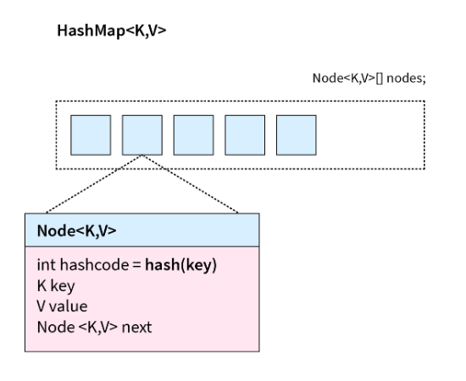

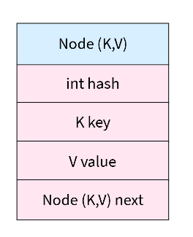

### **Rehashing**

* Rehashing is the process of re-calculating the hash code of already stored entries.
* When the number of entries in the hash table exceeds the threshold value, the Map is rehashed so that it has approximately twice the number of buckets as before.
* e.g.,   
  Let's suppose a HashMap is created with the initial default capacity of 16

and the default load factor of 0.75.

So, the threshold is 16 * 0.75 = 12,

which means that it will increase the capacity from 16 to 32

after the 12th entry (key-value pair) is added.

This will be done by rehashing.

### **Hierarchy of HashMap**

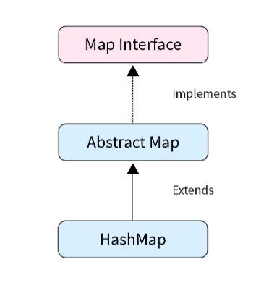

### **Declaration of HashMap**

public class **HashMap**<K,V> extends **AbstractMap**<K,V> **implements Map<K,V>, Cloneable, Serializable**

### **Create HashMap Syntax**

HashMap<K, V> hashmap = new HashMap<>();

e.g., HashMap<String, Integer> language= new HashMap<>();

### **Constructors in HashMap**

1. HashMap() -

* It is the default constructor.
* HashMap instance with a default initial capacity of 16.
* load factor is 0.75.
* e.g., HashMap<String, Integer> language= new HashMap<>();

1. HashMap(int initialCapacity) -

* It creates an instance of HashMap with a specified initial capacity.
* Load factor is 0.75.
* e.g., HashMap<Integer, String> hm1 = new HashMap<>(10);
* If threshold value(0.75) is exceeded then hm1 capacity will increase to 20. ie., will add 10 more memory sizes to existing HashMap.

1. HashMap(int initialCapacity, float loadFactor)

* It creates an instance of HashMap with a specified initial capacity and specified load factor.
* e.g., HashMap<Integer, String> hm1 = new HashMap<>(10, 0.5f);
* New threshold=(5∗0.5)=2.5, if threshold value is exceeded then more 5 index will add to the capacity. It will become 10.

1. HashMap(Map map)

* It creates an instance of HashMap using another Map.
* e.g., HashMap<K, V> hm = new HashMap<K, V>(Map map);
* hm and map both will have the same values, capacity and load factor.

| 1 | V put(K key, V value) | Associates the specified value with the specified key in this map. |
| --- | --- | --- |
| 2 | void putAll(Map<? extends K,? extends V> m) | Copies all of the mappings from the specified map to this map. |
| 3 | V putIfAbsent(K key, V value) | If the specified key is not already associated with a value (or is mapped to null),  associates it with the given value and returns null, else returns the current value. |
| 4 | V get(Object key) | Returns the value to which the specified key is mapped,  or null if this map contains no mapping for the key. |
| 5 | V getOrDefault(Object key, V defaultValue) | Returns the value to which the specified key is mapped,  or defaultValue if this map contains no mapping for the key. |
| 6 | Set keySet() | Returns a Set view of the keys contained in this map. |
| 7 | Set entrySet() | Returns a Set view of the mappings contained in this map. |
| 8 | V remove(Object key) | Removes the mapping for the specified key from this map if present. |
| 9 | boolean isEmpty() | Returns true if this map contains no key-value mappings. |
| 10 | boolean containsKey(Object key) | Returns true if this map contains a mapping for the specified key. |
| 11 | boolean containsValue(Object value) | Returns true if this map maps one or more keys to the specified value. |
| 12 | void clear() | Removes all of the mappings from this map. |
| 13 | Object clone() | Returns a shallow copy of this HashMap instance:  the keys and values themselves are not cloned. |
| 14 | boolean remove(Object key, Object value) | Removes the entry for the specified key only if it is currently mapped to the specified value. |
| 15 | V replace(K key, V value) | Replaces the entry for the specified key only if it is currently mapped to some value. |
| 16 | boolean replace(K key, V oldValue, V newValue) | Replaces the entry for the specified key only if currently mapped to the specified value. |
| 17 | void replaceAll(BiFunction<? super K,  ? super V,? extends V> function) | Replaces each entry's value with the result of invoking the given function on that entry  until all entries have been processed or the function throws an exception. |
| 18 | int size() | Returns the number of key-value mappings in this map. |
| 19 | Collection values() | Returns a Collection view of the values contained in this map. |
| 20 | void forEach(BiConsumer<? super K,  ? super V> action) | Performs the given action for each entry in this map until all entries  have been processed or the action throws an exception. |
| 21 | V compute(K key, BiFunction<? super K,  ? super V,? extends V> remappingFunction) | Attempts to compute a mapping for the specified key and  its current mapped value (or null if there is no current mapping). |
| 22 | V computeIfAbsent(K key, Function<? super K,  ? extends V> mappingFunction) | If the specified key is not already associated with a value (or is mapped to null),  attempts to compute its value using the given mapping function and  enters it into this map unless null. |
| 23 | V computeIfPresent(K key, BiFunction<? super K,  ? super V,? extends V> remappingFunction) | If the value for the specified key is present and non-null,  attempts to compute a new mapping given the key and its current mapped value. |
| 24 | V merge(K key, V value, BiFunction<? super V,  ? super V,? extends V> remappingFunction) | If the specified key is not already associated with a value or  is associated with null, associates it with the given non-null value. |

## **LinkedHashMap**

* It is the Child Class of HashMap.
* It is Exactly Same as HashMap Except the following differences.

| HashMap | LinkedHashMap |
| --- | --- |
| The Underlying Data Structure is Hashtable. | The Underlying Data Structure is Combination  of Hashtable and LinkedList. |
| Insertion is Not Preserved | Insertion Order is Preserved. |
| Introduced in 1.2 Version | Introduced in 1.4 Version. |

## **IdentityHashMap**

* It is exactly the same as HashMap except the following Difference.
  + **In HashMap**, JVM will **use .equals()** **to Identify Duplicate Keys**, which is Meant for Content Comparison.
  + **In IdentityHashMap**, JVM will **use == Operator to Identify Duplicate Keys, which is Meant for Reference Comparison.**

IdentityHashMap<String, Integer> im = new IdentityHashMap<String, Integer>();

String s1 = new String("10");

String s2 = new String("10");

im.put(s1, 10);

im.put(s2, 20);

for(Entry<String, Integer> i : im.entrySet()) {

System.out.println(i);

}

Output :

10=10

10=20

## **WeakHashMap**

It is Exactly Same as HashMap Except the following Difference.

* In Case of **HashMap**, HashMap Dominates Garbage Collector. That is **if Object doesn’t**

**have any Reference** Still it is **Not Eligible for Garbage Collector** if it is associated with

HashMap.

* But In Case of **WeakHashMap** if an **Object doesn't contain any References then it is Always Eligible for GC** Even though it is associated with WeakHashMap. That is, Garbage Collector Dominates WeakHashMap.

## **SortedMap**

* It is the **Child Interface of Map**.
* If we want to Represent a Group of Key - Value Pairs According Some **Sorting Order** of keys then we should go for SortedMap.
* Specific methods defined in SortedMap  
   1) Object **firstKey**();

2) Object **lastKey**();

3) SortedMap **headMap**(Object key)

4) SortedMap **tailMap**(Object key)

5) SortedMap **subMap**(Object key1, Object key2)

6) Comparator **comparator**()

## **TreeMap**

* The Underlying Data Structure is Red -Black Tree
* Duplicate Keys are Not Allowed. But Values can be Duplicated.
* Insertion Order is Not Preserved and it is Based on Some Sorting Order of Keys.
* If we are depending on Default Natural Sorting Order then the Keys should be Homogeneous and Comparable. Otherwise we will get a Runtime Exception Saying ClassCastException.
* If we define Our Own Sorting by Comparator then Keys can be Heterogeneous and NonComparable.
* But there are No Restrictions on Values. They can be Heterogeneous and Non-Comparable.

Null Acceptance

* For Empty TreeMap as the 1st Entry with null Key is Allowed.
* But After inserting that Entry if we are trying to Insert any Other Entry we will get RE: NullPointerException
* For Non- Empty TreeMap if we are trying to Insert null Entry then we will get Runtime

Exception Saying NullPointerException

* There are No Restrictions on null Values.

Constructors:

1) TreeMap t = new TreeMap(); // For Default Natural Sorting Order.

2) TreeMap t = new TreeMap(Comparator c); // For Customized Sorting Order.

3) TreeMap t = new TreeMap(SortedMap m); // InterConversion between Map Objects.

4) TreeMap t = new TreeMap(Map m);

## **HashTable**

* Underlying **data structure is Hashtable** only.
* **Duplicate keys are not allowed.** But **values** can be **duplicated**.
* **Insertion order is not preserved** and it's **based on the hashcode** of the key.
* **Heterogenous keys and values are allowed**.
* **Null insertion is not allowed for keys and values** otherwise we will get an exception NullPointerException.
* Every **method** in the hashtable **is Synchronized**. Hence **Hashtable objects are thread safe.**
* Considered a "**legacy class**".

### **Declaration**

#### public class Hashtable<K,V>

#### extends Dictionary<K,V>

#### implements Map<K,V>, Cloneable, Serializable

### **Internal Working**

#### 

* A Hashtable is an array of a list.
* Each list referred to a bucket. And that list contains key/value pairs.
* It uses the hashCode() method for identifying which bucket should be assigned to the key/value combination.
* The equals() function is used by the hashtable to detect if two items are equal or not.

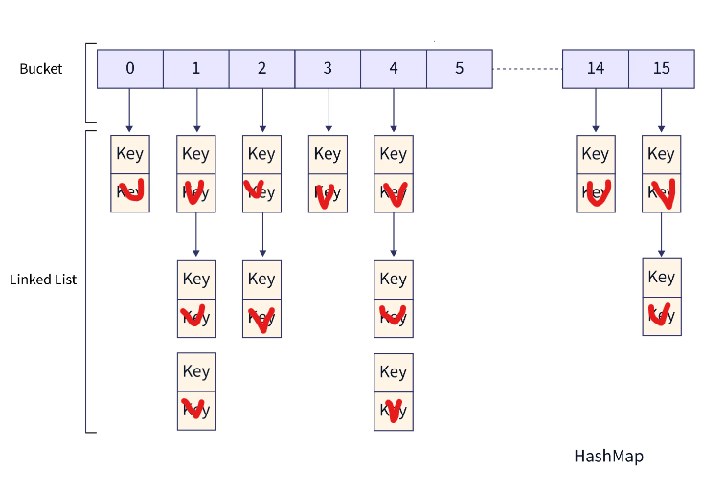

* Each entry in an array is called a bucket.
* Each value is linked with a bucket value by following formula  
  Hash_number % Number of buckets = Index of Bucket 12 % 10 == [2]
* Multiple data values may collide at and be linked from the same bucket.  
  eg., 12%10 = 2 , and 42%10 = 2
* Most hash tables manage collisions by comparing the whole value of a value being searched or added to each value existing in the linked list at the hashed-to bucket.This results in somewhat decreased speed but no functional confusion

### **Constructors**

1. HashTable h = new HashTable();
   1. It is the default constructor of a hash table that constructs a new and empty hashtable with a default initial capacity (11) and load factor (0.75).
2. Hashtable h = new Hashtable(int initialcapacity);
   1. It constructs a new, empty hashtable with the specified initial capacity and default load factor (0.75).
3. Hashtable h = new Hashtable(int initialcapacity, float fillRatio);
   1. It constructs a new, empty hashtable with the specified initial capacity and the specified load factor.
4. Hashtable h = new Hashtable(Map m);  
   1. It constructs a new hashtable with the same mappings as the given Map.

### **Methods Present in HashTable**

| 1 | Object put(Object key, Object value) | **add the specified key to the specified value in this hashtable.** |
| --- | --- | --- |
| 2 | putAll(Map<? extends K,? extends V> t) | **Copies all of the mappings from a given map to the hashtable.** |
| 3 | putIfAbsent(K key, V value) | **If the specified key is not already mapped with a value,**  **maps it with the given value and returns null,**  **else returns the current mapped value.** |
| 4 | Object get(Object key) | **Returns the value to which the specified key is mapped,**  or null if the hashtable contains no mapping for the key. |
| 5 | getOrDefault(Object key, V defaultValue) | **Returns the value to which the given key is mapped, or**  **defaultValue if the hashtable contains no mapping for the key.** |
| 6 | void clear() | **Removes all the key-value mappings** from a Hashtable and **makes it empty.** |
| 7 | Object clone() | Creates a **shallow copy of the hashtable.** **All the structure of the hashtable itself is copied,**  **but the keys and values are not cloned.**  This is a relatively expensive operation. |
| 8 | boolean containsValue(Object value) | **Tests if the specified object is a value in the hashtable.**  Returns true if some value equal to the specified value exists within the hash table.  Returns false if the value isn’t found. |
| 9 | boolean containsKey(Object key) | **Tests if the specified object is a key in this hashtable.** |
| 10 | boolean contains(Object value) | **Tests if some key maps into the specified value in this hashtable.**  This operation is more expensive than the containsKey method.  Note that this method is identical in functionality to containsValue,  (which is part of the Map interface in the collections framework) |
| 11 | boolean isEmpty() | **Tests if the hashtable maps no keys to values.** |
| 12 | void rehash() | **Increases the size of the hash table and rehashes all of its keys.** |
| 13 | Object remove(Object key) | **Removes the key** (and its corresponding value) from this hashtable. |
| 14 | int size() | **Returns the number of key-value mappings present in Hashtable**. |
| 15 | String toString() | Returns the objects of Hashtable in the form of a set of key-value mappings separated by ",".  **The toString() method is used to convert all the elements of Hashtable into String.** |
| 16 | Enumeration keys() | **Returns an enumeration of the keys contained in the hash table.** |
| 17 | Enumeration elements() | **Returns an enumeration of the values contained in the hash table.** |
| 18 | hashcode() | **Returns the hash code value for the Map as per the definition in the Map interface.** |
| 19 | keySet() | **Returns a view of the keys contained in the hashtable as a set.** |
| 20 | entrySet() | **Returns a view of the mappings contained in the hashtable as a set.** |